Chapter 6, Solution 85.

It is evident that differentiating i will give a waveform similar to v. Hence,
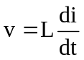

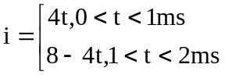

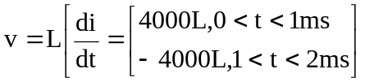

But, 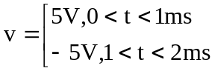

Thus, 4000L = 5 L = 1.25 mH in a 1.25 mH inductor

